Flow 1:

The basic one:

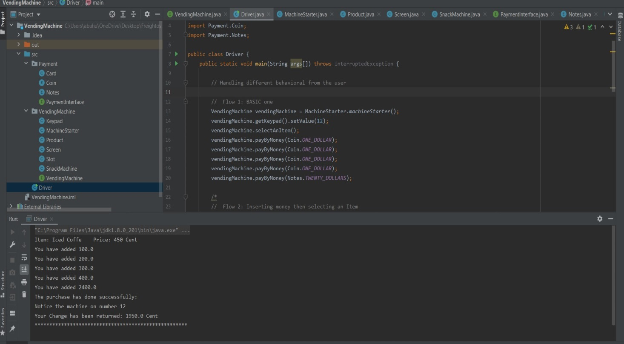

1. The user select the item number using the keypad
2. Confirm selection
3. Inserting money until inserted money > price
4. Vending machine will do the rest and gives you the snack

Flow 2:

Inserting money before selecting an item:

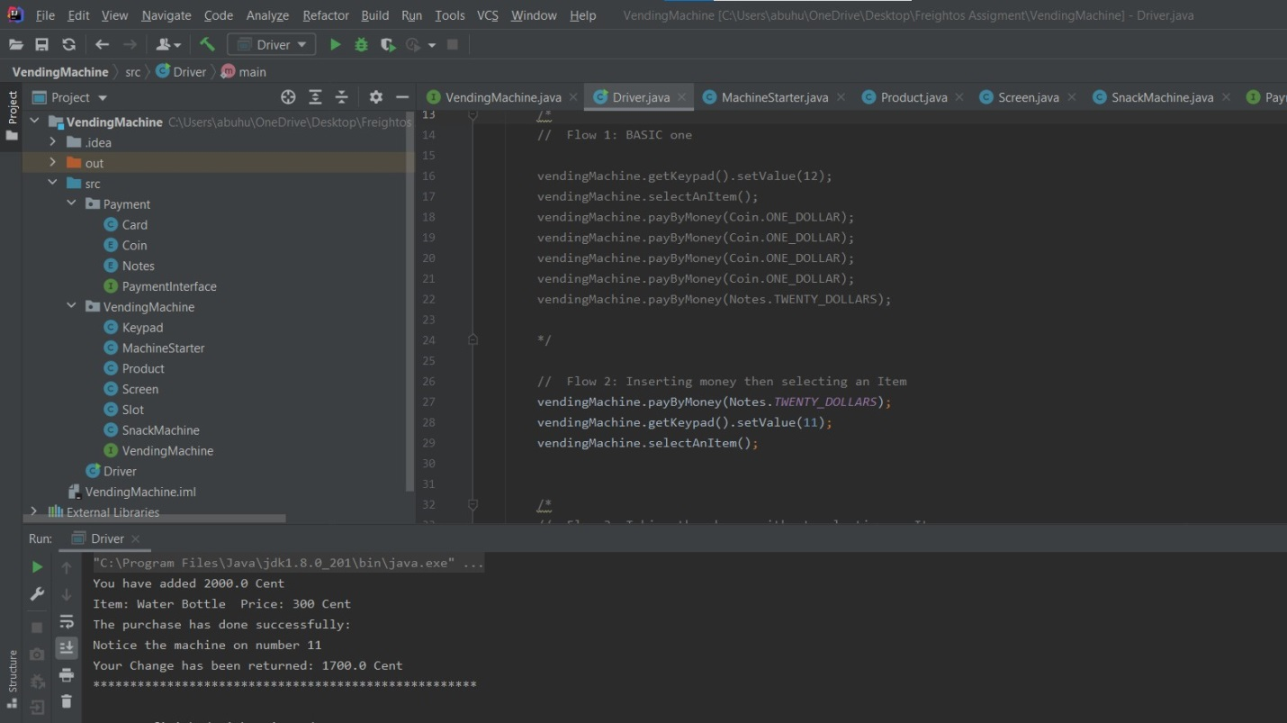

1. User Inserts money
2. When selecting an item: machine checks money is enough or not
3. If true: Enjoy your snack

Flow 3:

Dispensing change without buying:

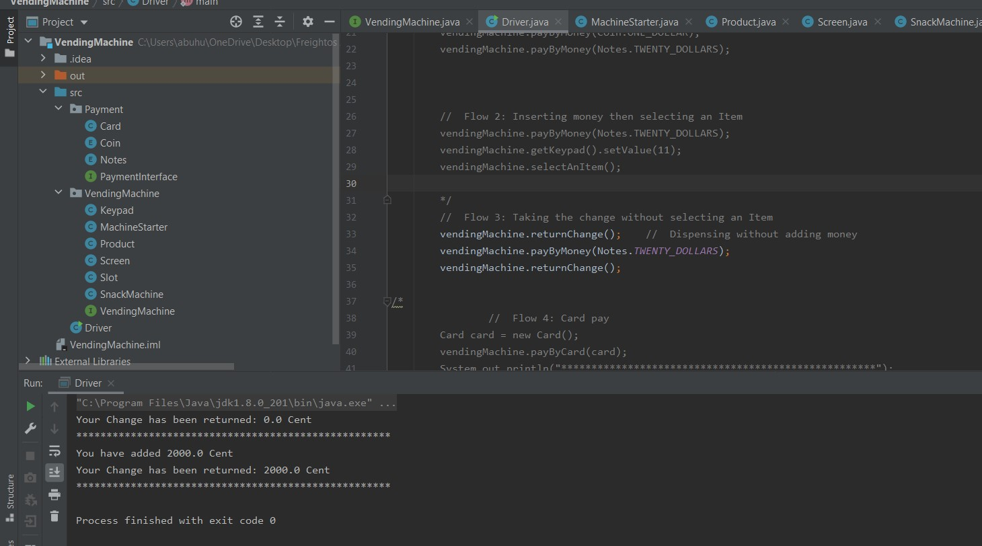

Case 1:

1. When no money entered and try to dispense money
2. No money will be returned

Case 2:

1. When entering money try to dispense without buying
2. Your money will be returned

Flow 4:

Paying using credit card:

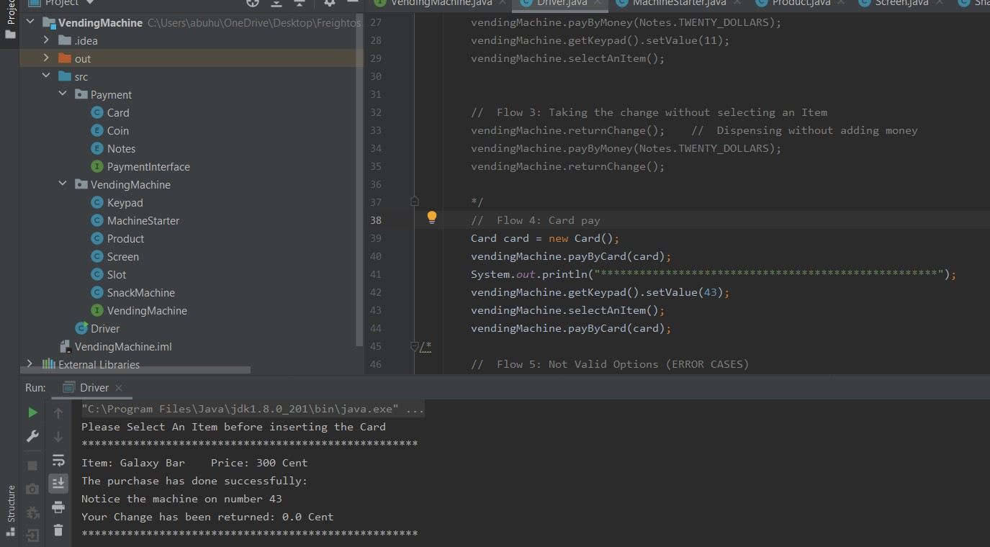

Case 1:

1. When card is put before entering the wanted item number
2. The card will come out and won’t buy

Case 2:

1. When card is put after entering the wanted item number
2. The machine will cut-out the price from the balance if balance > price

Flow 5:

The non-valid options:

1. Purchasing from empty inventory

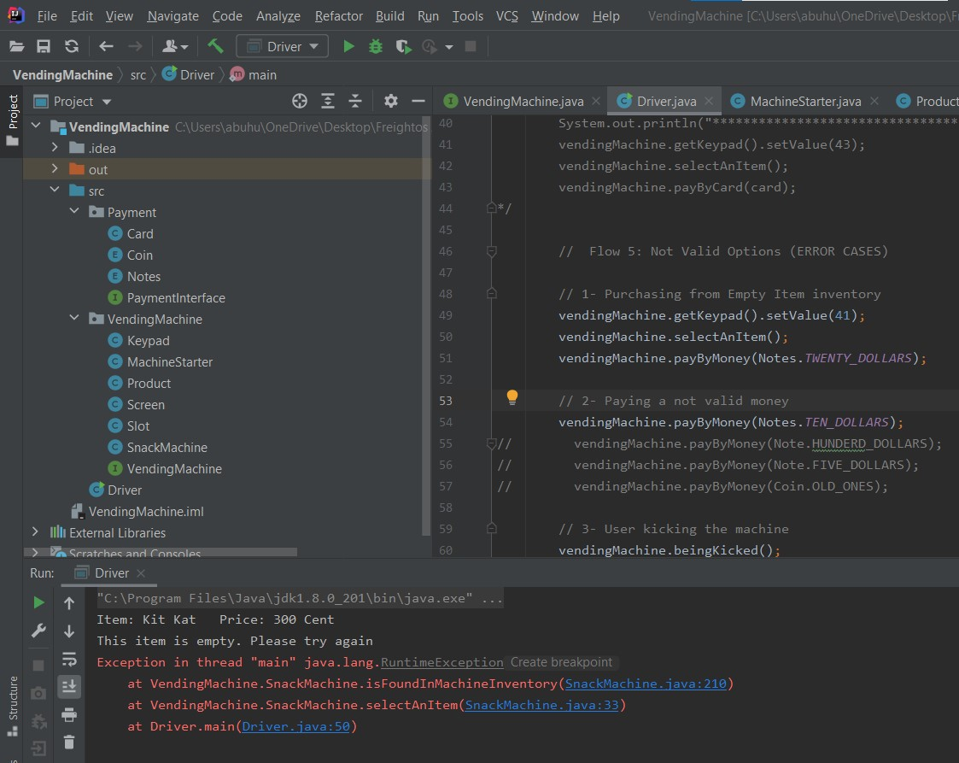

1. Inserting a non-valid money type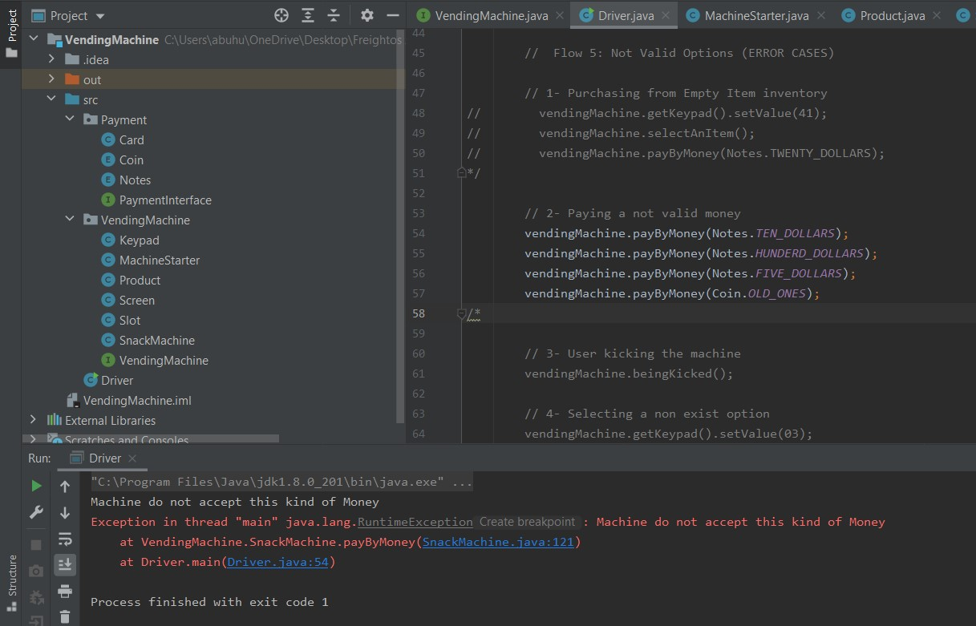
2. Kicking the machine

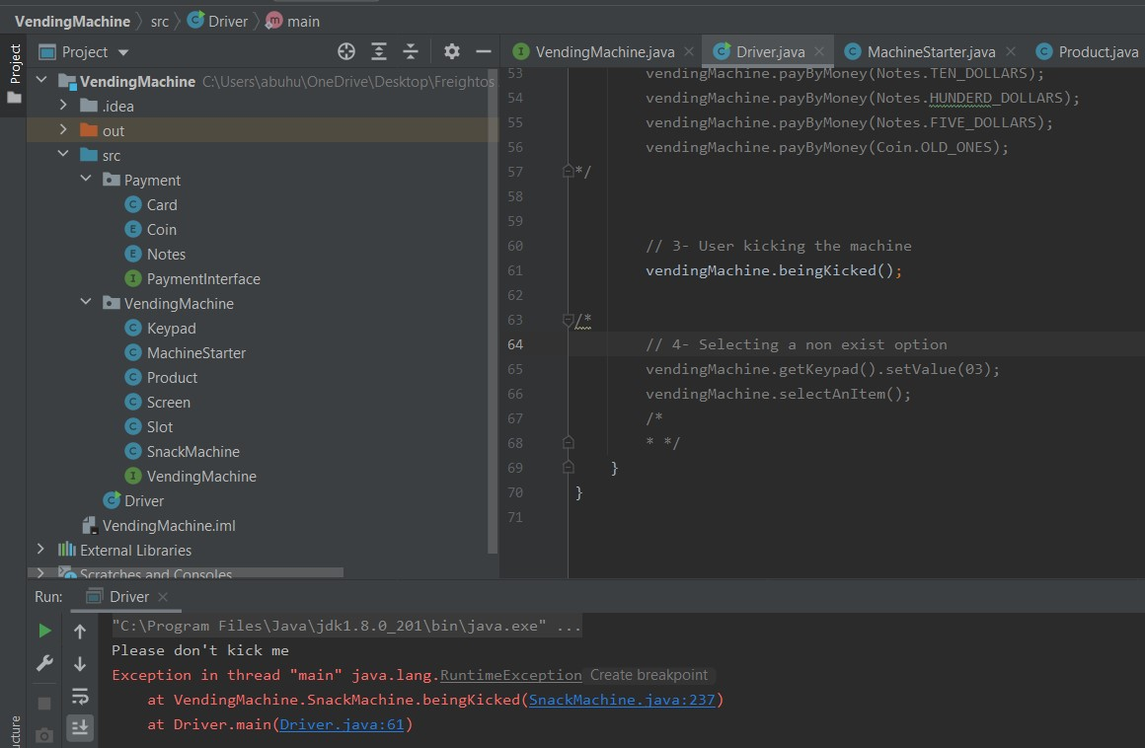

1. Selecting a non-exist option: